UI/UX
  - HOBBFYY – A SOCIAL DISCOVERY APP

INTRODUCTION:
Hobbyfy is a mini UI/UX project designed to create a digital space where people can explore, buy, and sell hobby-related products. The app aims to connect hobby enthusiasts with creators by offering a smooth and engaging shopping experience. Whether a user is looking for ready-made kits, handmade crafts, or wants to sell their own creations, Hobbyfy simplifies the process with clear navigation, modern design, and user-friendly features.
This project has been developed using Jesse James Garrett’s 5 Planes of User Experience framework — Strategy, Scope, Structure, Skeleton, and Surface. Each plane guided the design process step by step, ensuring that the final product aligns with both user needs and business goals.
TEAM MEMBERS:
Anuja Kharat
Aastha Meher
Adishree Khamgaonkar
Darpan Kondagekar
Kshiti Vartak
Viraj Kamble
APPLYING THE 5 S’S OF UX IN HOBBYFY:
Strategy
The foundation of Hobbyfy lies in a clear strategy that balances business goals with user needs. The vision of the app is to create a dedicated platform where hobbyists can explore, buy, and sell hobby-related products in a seamless way. The business objective is to encourage users to turn hobbies into passions or even side businesses by providing them with an accessible digital marketplace. From the user’s perspective, the need is for simple product discovery, reliable information, and a smooth buying or selling process. This strategy ensures that the design remains both purpose-driven and user-centered.

Scope
The scope of Hobbyfy defines the specific features and functionalities included in the app. The Shop page was designed to allow browsing across categories, applying filters, sorting items, and viewing recommendations. The Item Details page provides clear descriptions, pricing, delivery details, ratings, and reviews, ensuring that users have all the information they need before making a purchase. On the seller’s side, the app includes an option to upload product details, preview them, and publish listings. Additional supporting features such as a wishlist and rating system further enrich the user experience, while features like community and tutorials are reserved for possible future expansion.

Structure
At the structural level, Hobbyfy organizes information and defines how users move through the system. For shoppers, the flow follows a simple sequence: browse or search for items, filter or sort results, view product details, add items to the cart, and proceed to checkout. For sellers, the flow includes navigating to the sell option, uploading details, previewing the listing, and publishing the product. This logical arrangement ensures that users can progress smoothly from exploration to decision-making and finally to action, without unnecessary complexity or confusion.

Skeleton
The skeleton defines the layout, placement of elements, and navigation design. Hobbyfy makes use of a bottom navigation bar with access to key sections such as Shop, Sell, Cart, and Profile. On the Shop page, the layout emphasizes a top search bar with filter and sort options, followed by product cards that display images, prices, and ratings. On the Item Details page, a large product image is placed at the top, followed by price and quantity options, an “Add to Cart” button, and collapsible sections for details, shipping, and reviews. Consistency in the placement of navigation elements and buttons improves usability and creates a predictable experience for users.

Surface
The surface plane brings the final look and feel of Hobbyfy to life. A clean and calming visual style was chosen, with a color scheme based on soft blues and whites that reflect creativity and simplicity. Typography is minimal and clear to enhance readability, while intuitive icons support easy navigation. High-quality product images build trust, making items more appealing to users. To make the interface engaging, micro-interactions such as smooth animations during add-to-cart actions were introduced. Together, these visual and interactive elements ensure that Hobbyfy delivers a polished, professional, and user-friendly experience.
OUTPUT:
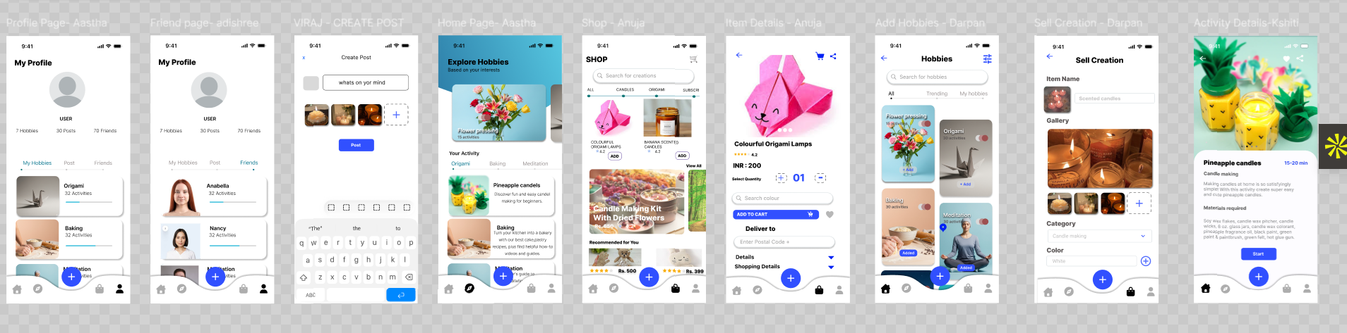
FEATURES OF HOBBYFY:
- User-Friendly Navigation – Bottom navigation bar with quick access to Shop, Sell, Cart, and Profile.
- Search & Filters – Powerful search bar with category filters and sorting options (price, ratings, popularity).
- Product Discovery – Browse hobby kits and creations with personalized recommendations and best-seller highlights.
- Product Details – Large product images, clear descriptions, pricing, reviews, FAQs, and delivery/shipping details.
- Wishlist – Save items for later purchase.
- Cart Management – Add, remove, and edit items easily before checkout.
- Selling Feature – Upload images, add details, preview listings, and publish products for sale.
- Ratings & Reviews – Build trust with customer feedback and star ratings.
- Stock & Delivery Info – Show availability and estimated delivery times.
- Related Items – Suggestions for similar or complementary products.
- Micro-interactions – Smooth animations for actions like adding to cart, switching tabs, and expanding details.
- Consistent UI Design – Clean layout, calming color palette, and intuitive icons across all pages.
CONCLUSION:
The design of Hobbyfy was guided by the five planes of user experience, moving step by step from strategy to surface. The Strategy clarified the purpose and user needs, while the Scope defined the features essential for achieving those goals. The Structure organized the flows for both shoppers and sellers, ensuring smooth navigation. The Skeleton refined the layout with consistent placement of elements and intuitive navigation, and finally, the Surface brought the design to life with a clean, calming visual style and engaging micro-interactions.
By carefully applying this framework, Hobbyfy delivers a user-friendly, visually appealing, and functional platform for hobbyists. It not only simplifies the process of discovering and purchasing hobby-related products but also empowers creators to share and sell their work. The project demonstrates how the systematic application of UX principles can transform an idea into a polished and purposeful digital experience.

